Food Management System

Version <1.0>

Revision History

|  |  |  |  |
| --- | --- | --- | --- |
| **Date** | **Version** | **Description** | **Author** |
| <24/12/2020> | <1.1> | Final Draft | Nguyen Thi Ngoc Anh |

Table of Contents

1. Introduction 2

1.1 Purpose 2

1.2 Scope 2

1.3 Definitions, Acronyms, and Abbreviations 2

1.4 References 2

1.5 Overview 2

2. Flow of Events—Design 2

3. Derived Requirements 2

# Introduction

## Purpose

This document describes how the Cancel Order Use-Case is realized within the design model, in terms of collaborating objects.

## Scope

This document applies to the Food Management System which will be developed by TAT Restaurant.

## Definitions, Acronyms, and Abbreviations

None.

## References

None.

## Overview

In the following section, Use-Case Realization Specification of the Cancel Order Use-Case of the Food Management System is provided in detail. The first section is a textual description of the Use-Case specification. The following section contains diagrams (sequence and collaboration diagrams) describing how the use case is realized in terms of collaborating objects. The third section includes class diagrams with relationships that participate in the realization of the use case. The last section is an analysis of all requirements, such as non-functional requirements, on the use-case realization that are not considered in the design model, but that need to be taken care of during implementation.

# Flow of Events—Design

**2.1. Use Case Specification (script)**

|  |  |
| --- | --- |
| **Use Case** | Cancel Order |
| **Description** | A customer cancel order that they have order |
| **Actor(s)** | Customer |
| **Flows of Events** |  |
| **Basic Flow** | |
| 1. The user goes to cancel order page.  2. The system get all orders in database as a list.  3. The user click Cancel in the order list for the user  4. The system returns to the order status view interface | |
| **Alternative Flows** | |
| None. | |
| **Pre-conditions** | |
| The user is logged in and the selected products have been ordered. | |
| **Post-conditions** | |
| **Title** | **Description** |
| Success | A page lists cancelled orders in database is displayed for the user. |
| Failure | The user is unable to cancel order when order status switch to Cooking mode |
| **Extension Points** | |
| None. | |

**2.2. Sequence Diagram:**

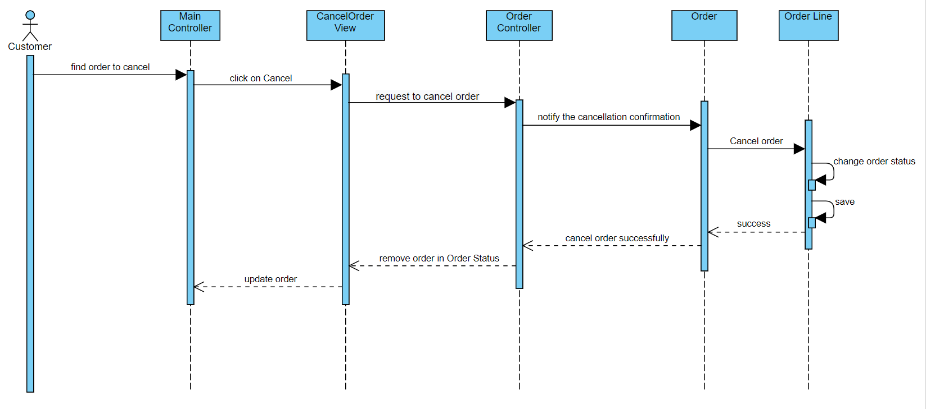

**2.3. Class Diagram:**

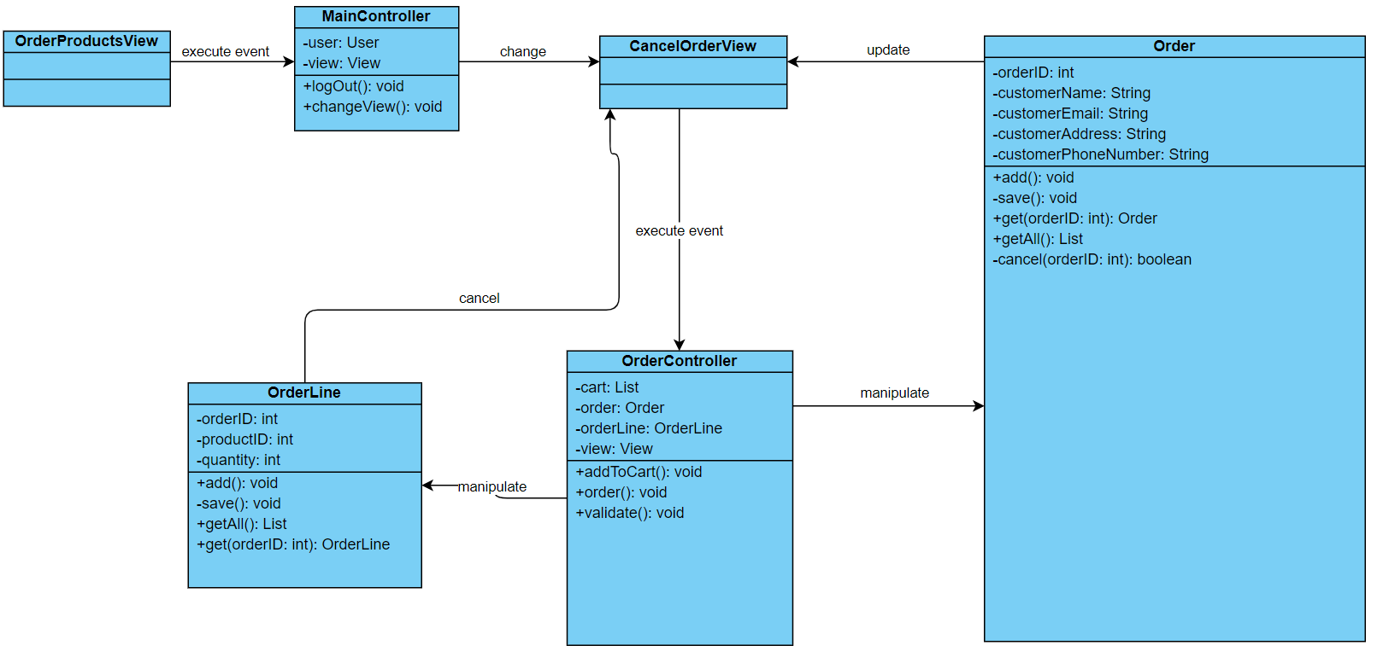

# Derived Requirements

None.